

**Name:** Sarthak Shinde

**Urn:** 2022-B-17012005

**Program:** B. Tech ITDS

**Semester:** 4

**Section:** B

**Subject:** Data Analytics using SQL

**Professor:** Dipmala Kamdi.

**Course Code:** DS206E

**ASSIGNMENT 1:**

|  |
| --- |
| **CUSTOMERS:** |
| Customer_id |
| First_name |
| Last_name |
| Email |
| Phone_no |

ER DIAGRAM:

|  |
| --- |
| **ORDERS:** |
| Order_id |
| Customer_id |
| Order_date |
| Order_total |

|  |
| --- |
| **FURNITURE**: |
| Furniture_id |
| Name |
| Description |
| Price |
| Category |

|  |
| --- |
| **ORDER_ITEMS:** |
| Order_item_id |
| Order_id |
| Furniture_id |
| Quantity |

**Database Schema:-**

**1. Customers table:**

Customer_id, First_name, Last_name, Email, Phone_number.

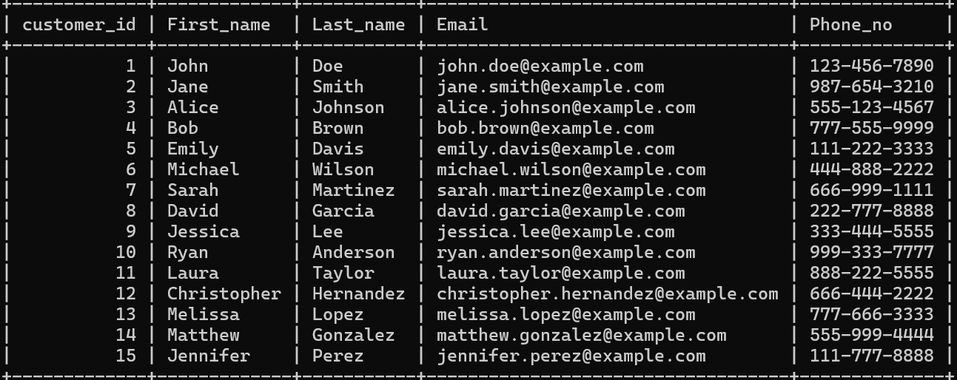

2. Orders table:

**Order_id, Customer_id, Order_date, Order_total**

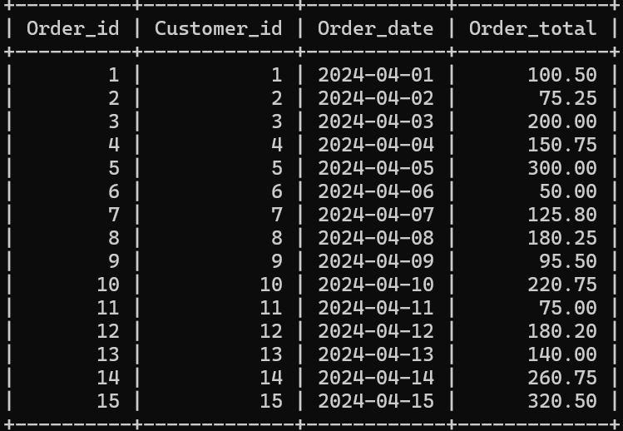

3. Products table:

Furniture_id | Name | Description | Price | Category

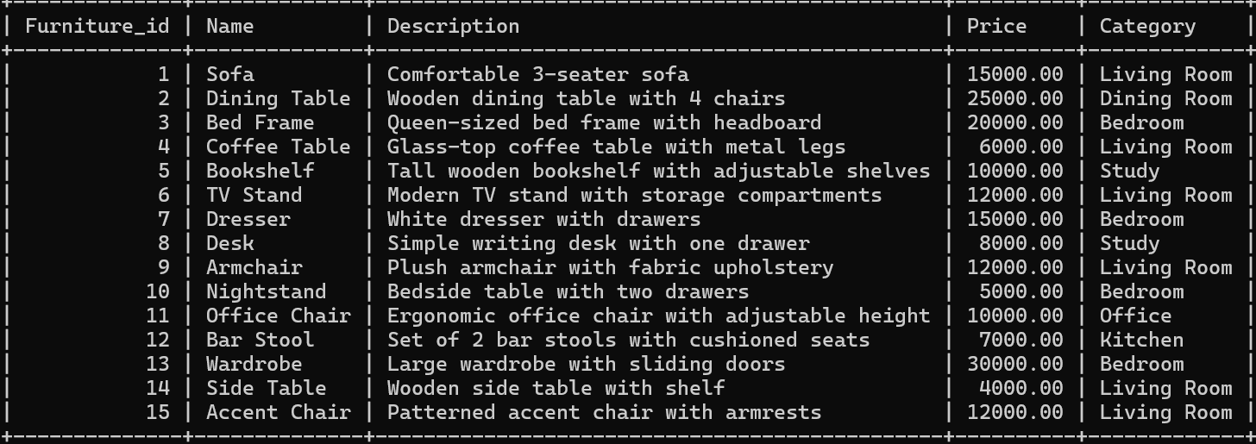

**4. Order items :**

Order_item_id | Order_id | Furniture_id | Quantity

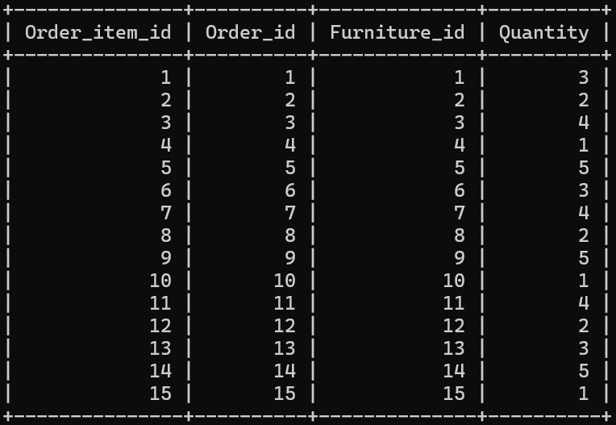

**Assignment 2**

**Questions:-**

**Let's consider only one table for generating 10 questions: -**

1.Find the most expensive item in each category.

2. Find the total price of all items in each category.

3. Find the average price of items in each category.

4. Find the number of items in each category.

5. Find the total number of items and the average price across all categories.

6. Retrieve the details (first name, last name, email) of customers whose phone numbers start with '555'.

7. Find the total number of customers in the database

8. List the customers whose email addresses end with '@gmail.com'.

9. Retrieve the customers sorted alphabetically by their last names

10. Calculate the average length of customer email addresses

**Let's consider only two tables for generating 10 questions:**

1. Retrieve the names and email addresses of customers who have placed orders
2. List the furniture items ordered along with their quantities and total order amounts
3. Find the total number of orders placed by each customer
4. Retrieve the details of customers who have not placed any orders
5. Calculate the total sales amount for each category of furniture
6. Find the top 5 customers with the highest total order amounts
7. Retrieve the furniture items that have not been ordered yet
8. Find the average order total for each customer
9. List the customers who have ordered furniture items in the "Living Room" category.
10. Retrieve the details of customers who have ordered a specific furniture item.

**Let's consider only three tables for generating 10 questions: -**

**Questions :-**

1.Find the total revenue generated from all orders.

2.Find the total number of items ordered.

3. Find the customer who placed the highest total order.

4. Find the most popular category of furniture based on the total quantity ordered.

5. Find the total revenue generated from orders placed in April 2024.

6. Find the average order total.

7. Find the top 3 highest-priced furniture items.

8.Find the customer who placed the earliest order.

9. Find the total quantity ordered for each furniture item.

10. Find the average price of furniture items ordered.

**Assignment 3**

Question 1: Find the most expensive item in each category.

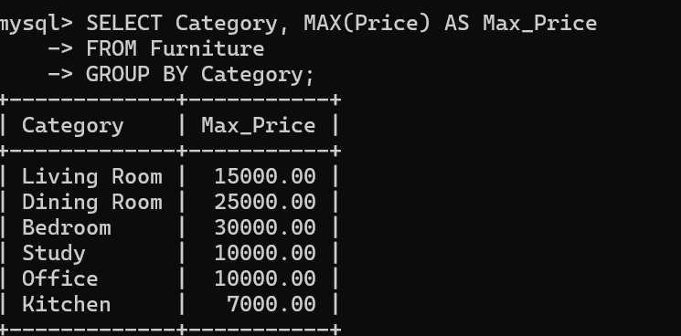

**Input:**

**Output:**

Question 2 : Find the total price of all items in each category:

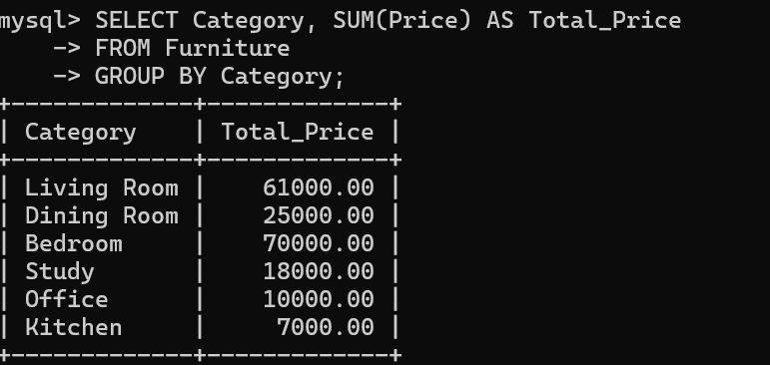 **input:**

**output:**

**Question 3 :** Find the average price of items in each category.

**Input:**

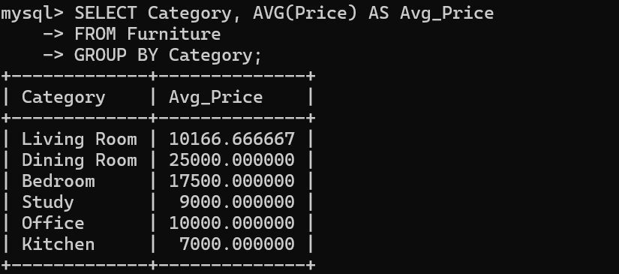**output:**

**Question 4.** Find the number of items in each category.

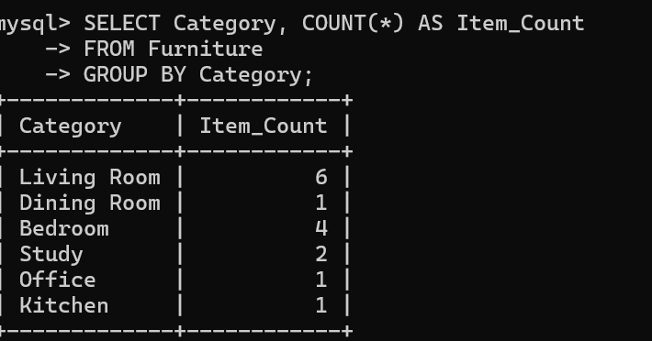

**Input:**

**Output:**

**Question 5**. Find the total number of items and the average price across all categories.

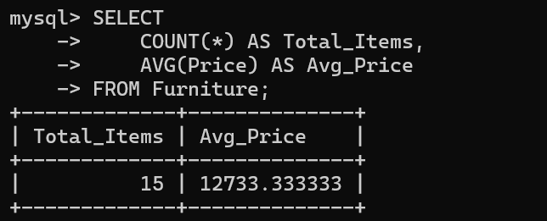 **input:**

**Output:**

**Question 6.** Retrieve the details (first name, last name, email) of customers whose phone numbers start with '555'.

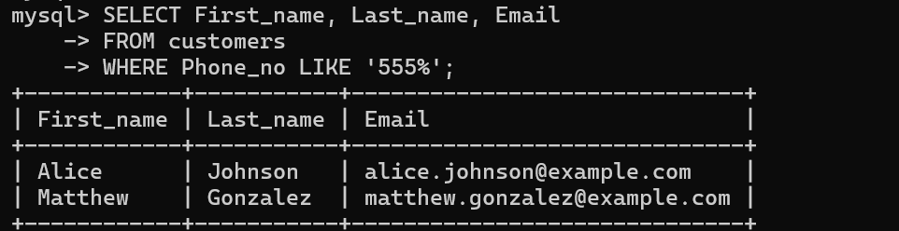 **input:**

**Output:**

**Question 7.** . Find the total number of customers in the database.

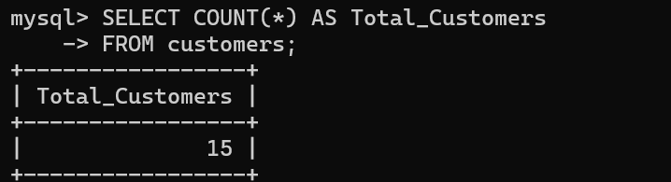 **Input:**

**Output:**

**Question 8.** Question: List the customers whose email addresses end with '@gmail.com'.

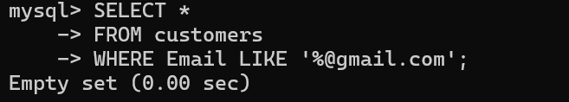

**Input:**

**Output:**

**Question 9.** Retrieve the customers sorted alphabetically by their last names

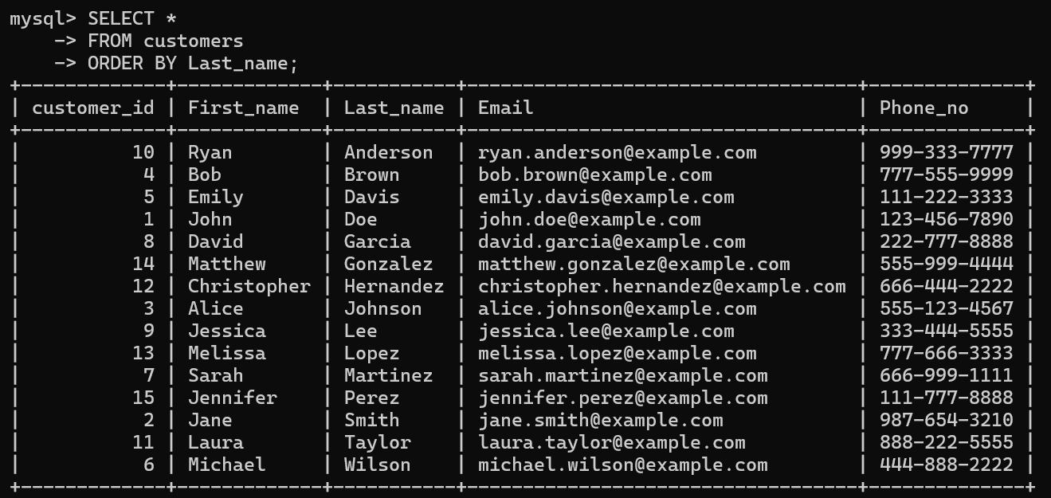

**Input:**

**Output:**

**Question 10 .**Calculate the average length of customer email addresses **:**

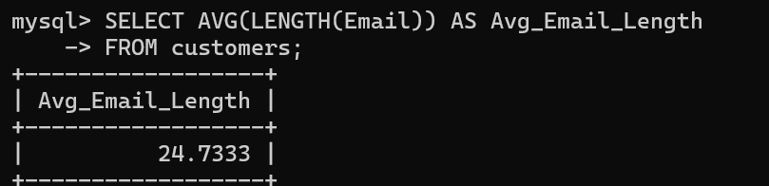

**Input:**

**Output:**

Assignment 4:

Question 1. Retrieve the names and email addresses of customers who have placed orders

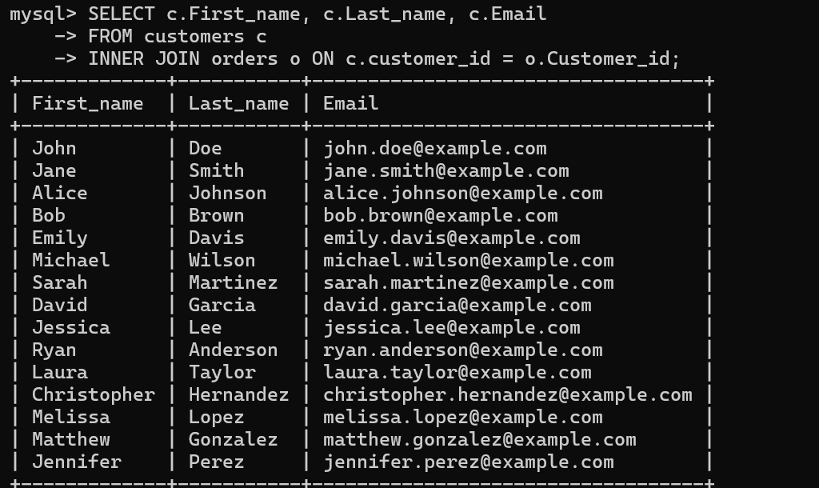Input:

Output:

Question 2. List the furniture items ordered along with their quantities and total order amounts.

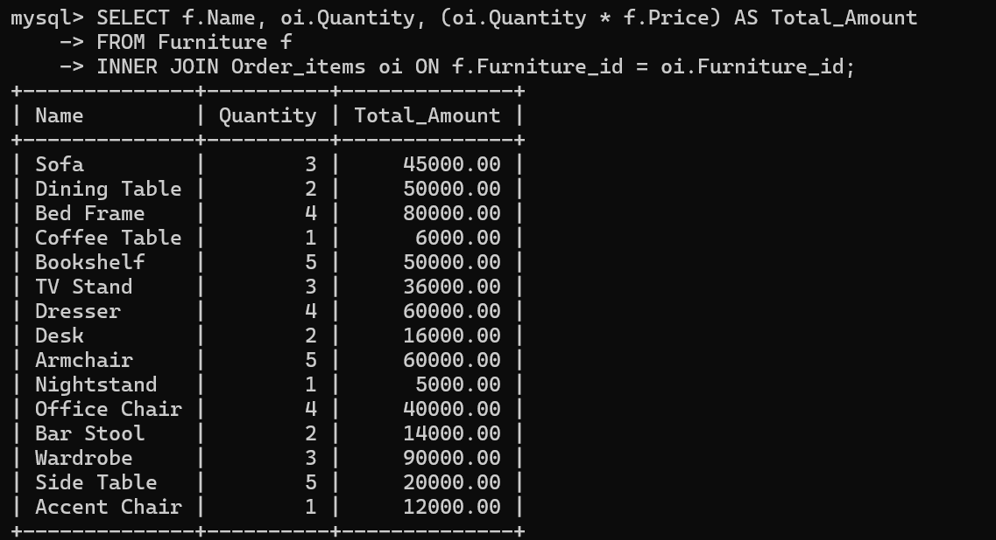Input:

Output:

Question 3. Find the total number of orders placed by each customer.

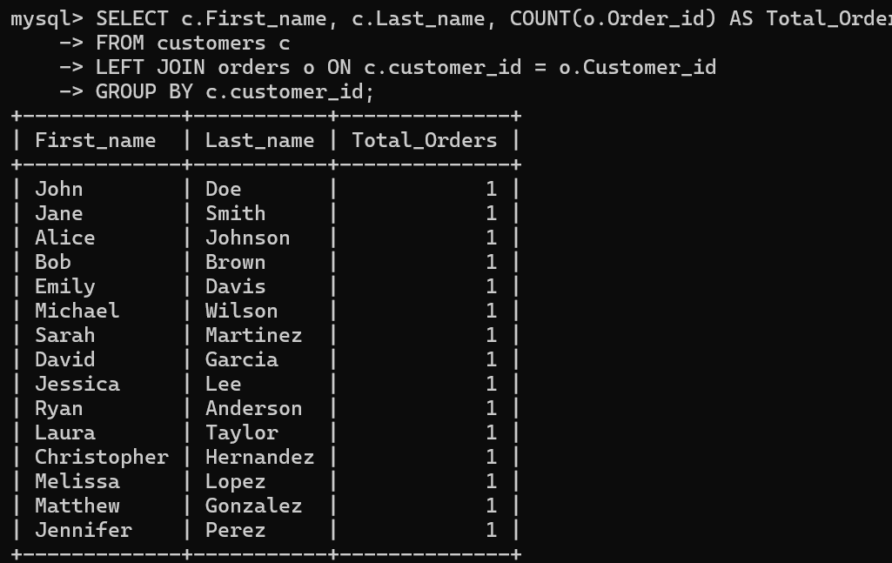

Input:

Output:

Question 4. Retrieve the details of customers who have not placed any orders.

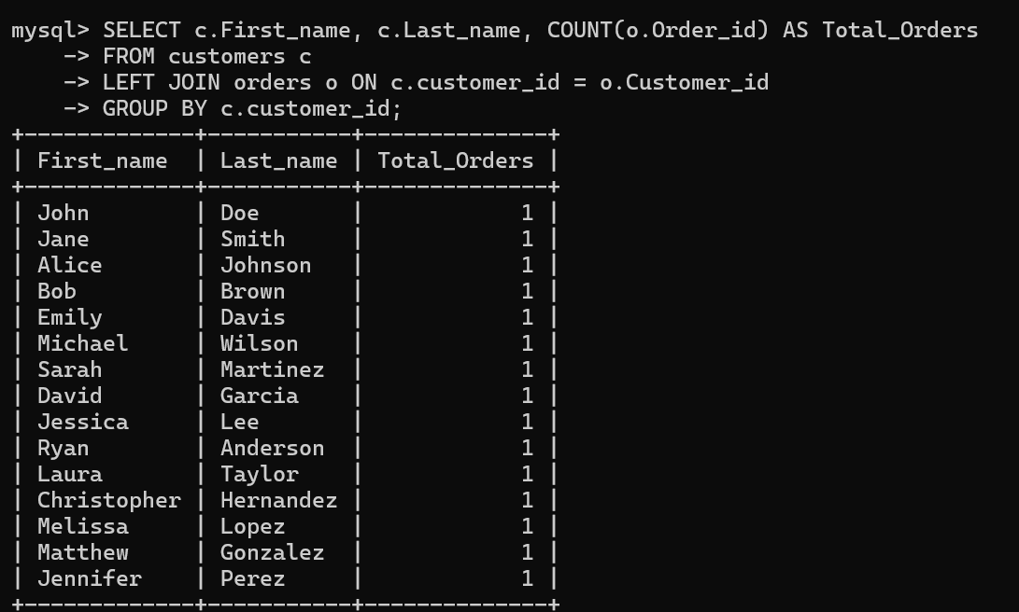Input:

Output:

Question 5. Calculate the total sales amount for each category of furniture.

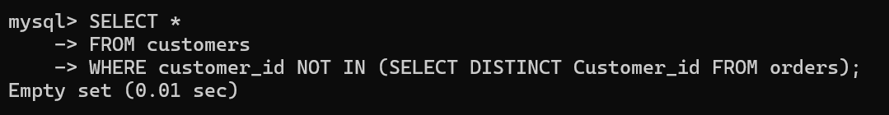Input:

Output:

Question 6. Find the top 5 customers with the highest total order amounts.

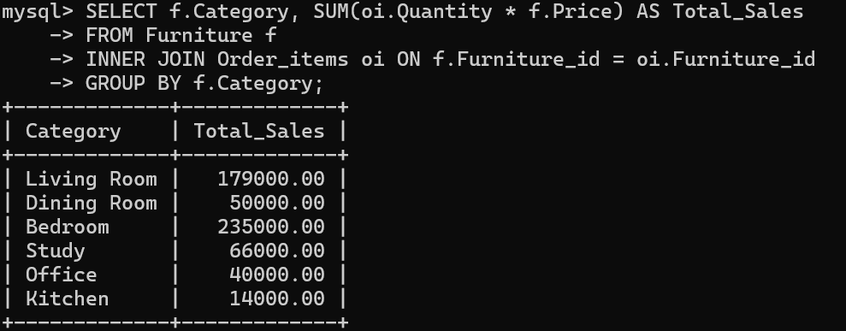Input:

Output:

Question 7. Retrieve the furniture items that have not been ordered yet.

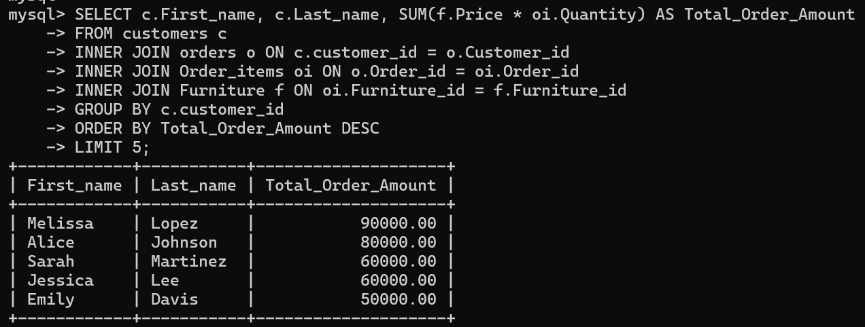

Input:

Output:

Question 8. Find the average order total for each customer.

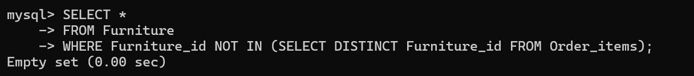Input:

Output:

**Question 9.** List the customers who have ordered furniture items in the "Living Room" category.

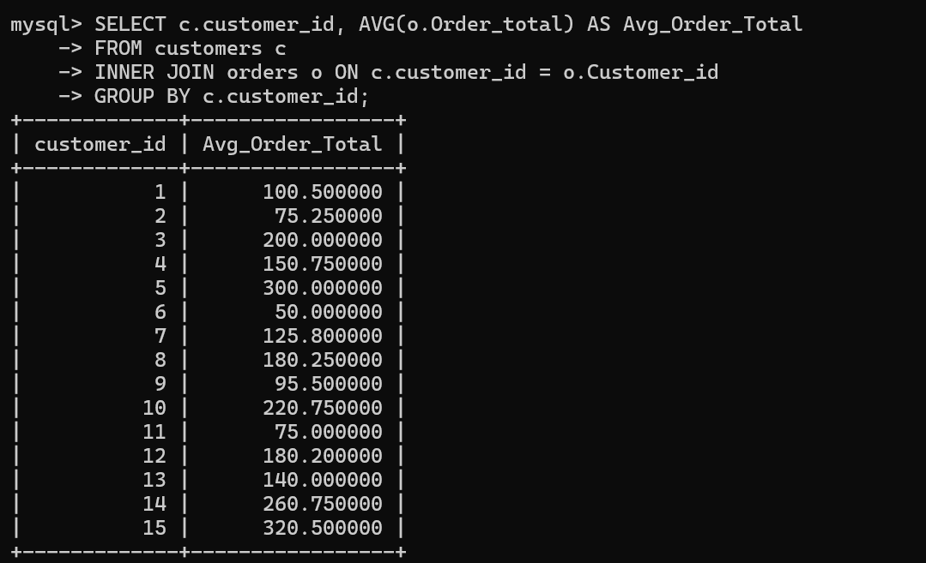Input:

Output:

Question 10. Retrieve the details of customers who have ordered a specific furniture item.

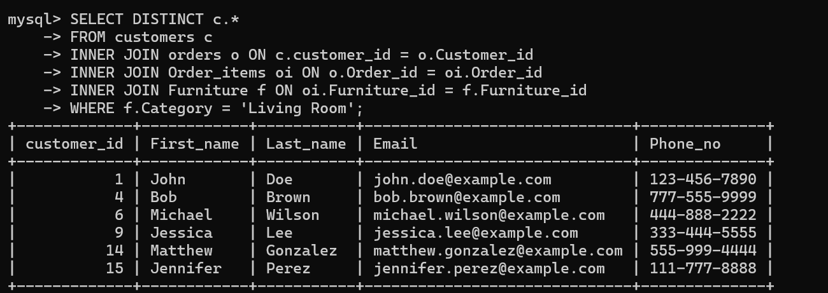Input:

Output:

Assignment 5 :

Question 1: Find the total revenue generated from all orders.

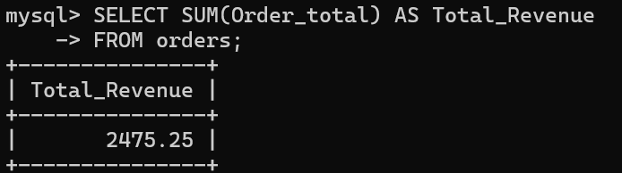

Input:

Output:

Question 2: Find the total number of items ordered.

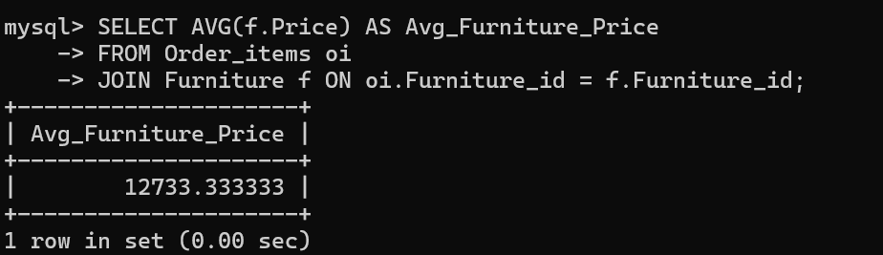

Input:

Output:

Question 3: Find the customer who placed the highest total order.

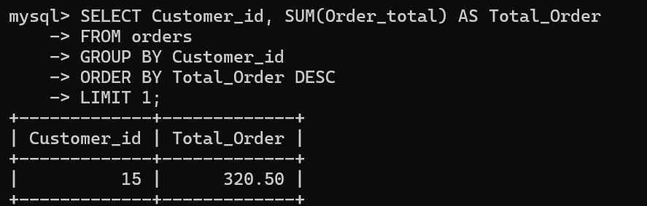

Input:

Output:

Question 4: Find the most popular category of furniture based on the total quantity ordered.

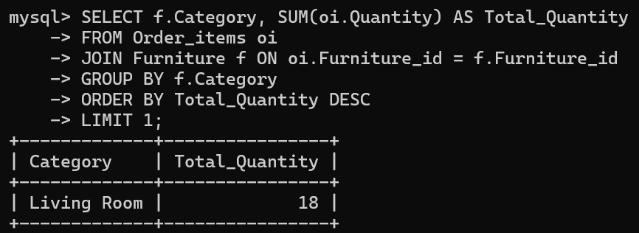

Input:

Output:

Question 5: Find the total revenue generated from orders placed in April 2024.

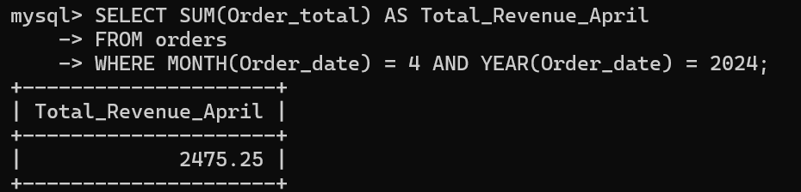Input:

Output:

Question 7: Find the average order total.

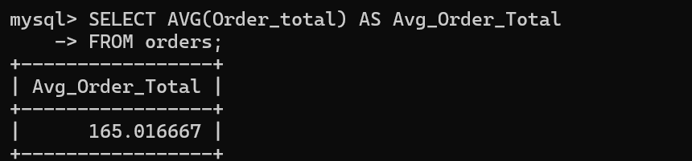

Input:

Output:

Question 8: Find the top 3 highest-priced furniture items.

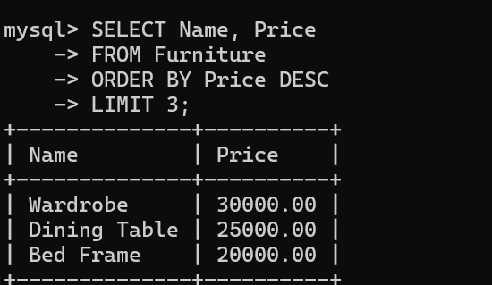

Input:

Output:

Question 9: Find the total quantity ordered for each furniture item.

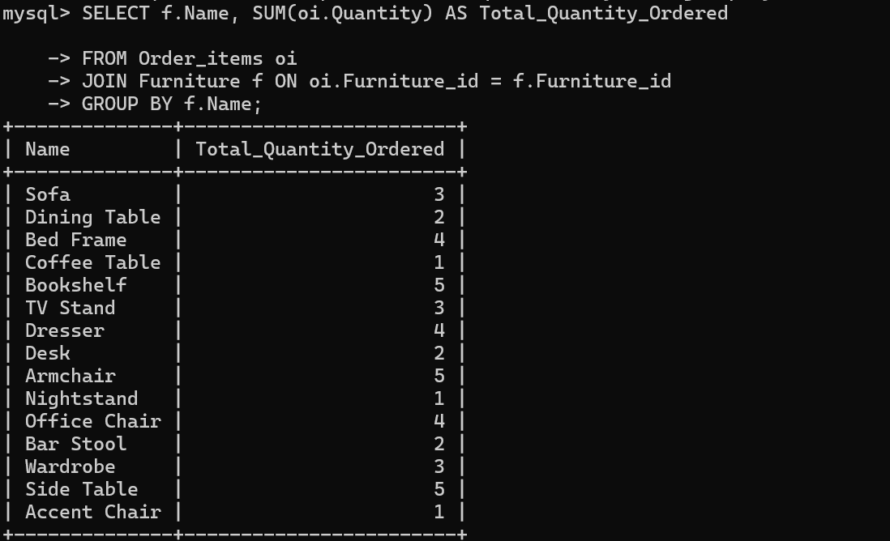

Input:

Output:

Question 10: Find the average price of furniture items ordered.



Input:

Output: